**T-Test:**

The T-test, which involves making inferences about population parameters based on sample data,

1. When the sample size is less than 30 and population standard deviation is not available.

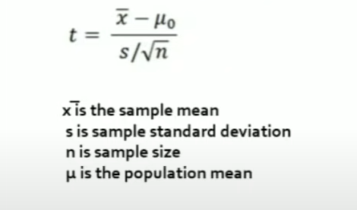

If the result of the T-Test is greater than the table value, then reject the null hypothesis

If the result of the T-Test is less than the table value, then the null hypothesis is accepted.

**Z -Test:**

The Z-test, which involves making inferences about population parameters based on sample data,

In all the below conditions we will use the Z-Test

1. if the sample is small and population variance should be known.

OR

1. if population variance is not known then sample size should be large

OR

1. Sample size is large and We know the standard deviation.

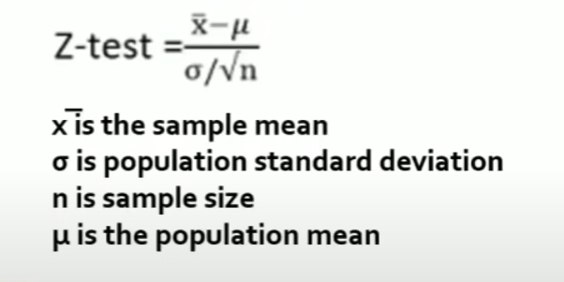

If the result of the Z-Test is greater than the table value, then reject the null hypothesis

If the result of the Z-Test is less than the table value, then the null hypothesis is accepted.

**F-TEST:**

The F-test (also known as Fisher's F-test) is used to compare the variances of two or more groups.

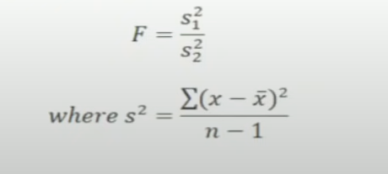

**Annona Test: -**

It is an extension of the Z-Test and T-Test: if we want to compare the mean of more than two datasets then we use Annona Test.

ANOVA is used for feature selection and feature importance analysis. When dealing with datasets that have multiple features, ANOVA can help determine which features are more important or influential in explaining the variability in the target variable.

**Chi-Square Test:**

The Chi-Square Test is a statistical test used to determine if there is a significant association between two categorical variables in the same data.